Git One
Vladyslav Sharapov (c00325055)
Group B
git init
This command used for initialise .git repository
git add
This command used to add changes in your working directory to the staging area before committing them
git status
This command displays the state of the working directory and the staging area. It shows which changes have been staged, which haven't, and which files aren't being tracked by Git
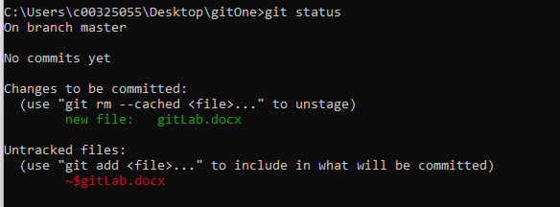
Git commit
This command creates the new commit containing the current contents of the index and the given log message describing the changes
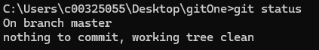
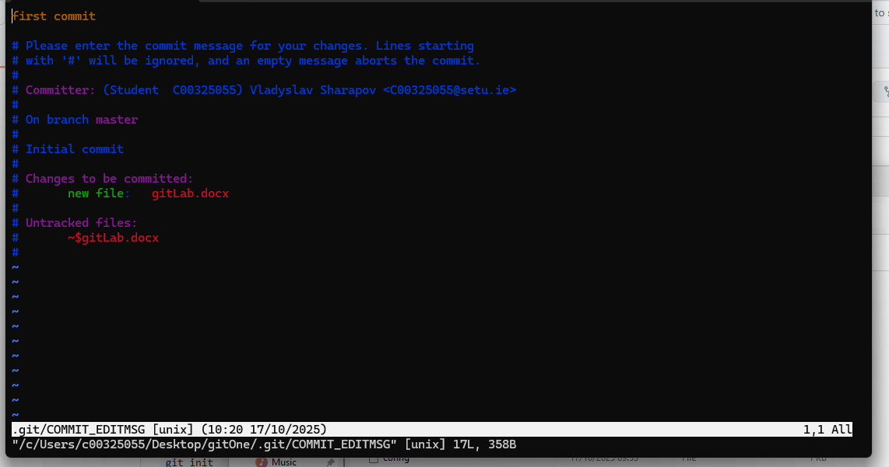
Git remote
This command is managing set of tracked repositories
Git push
This command pushed commited files to the branch
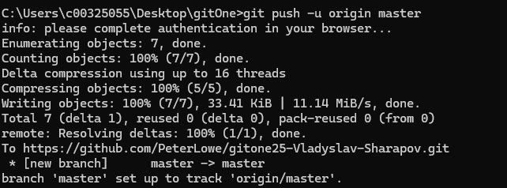
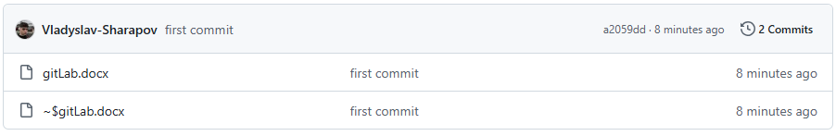
Git branch
This command is used to list, create, delete, and manage branches.
Git checkout
This command is used to switch branches or restore working tree files in Git. It updates files in the working tree to match the version in the index or the specified tree
